WHISHLIST:
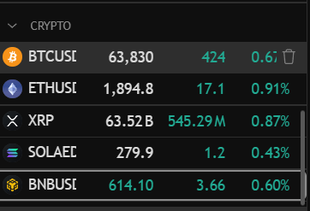

BINANCE:

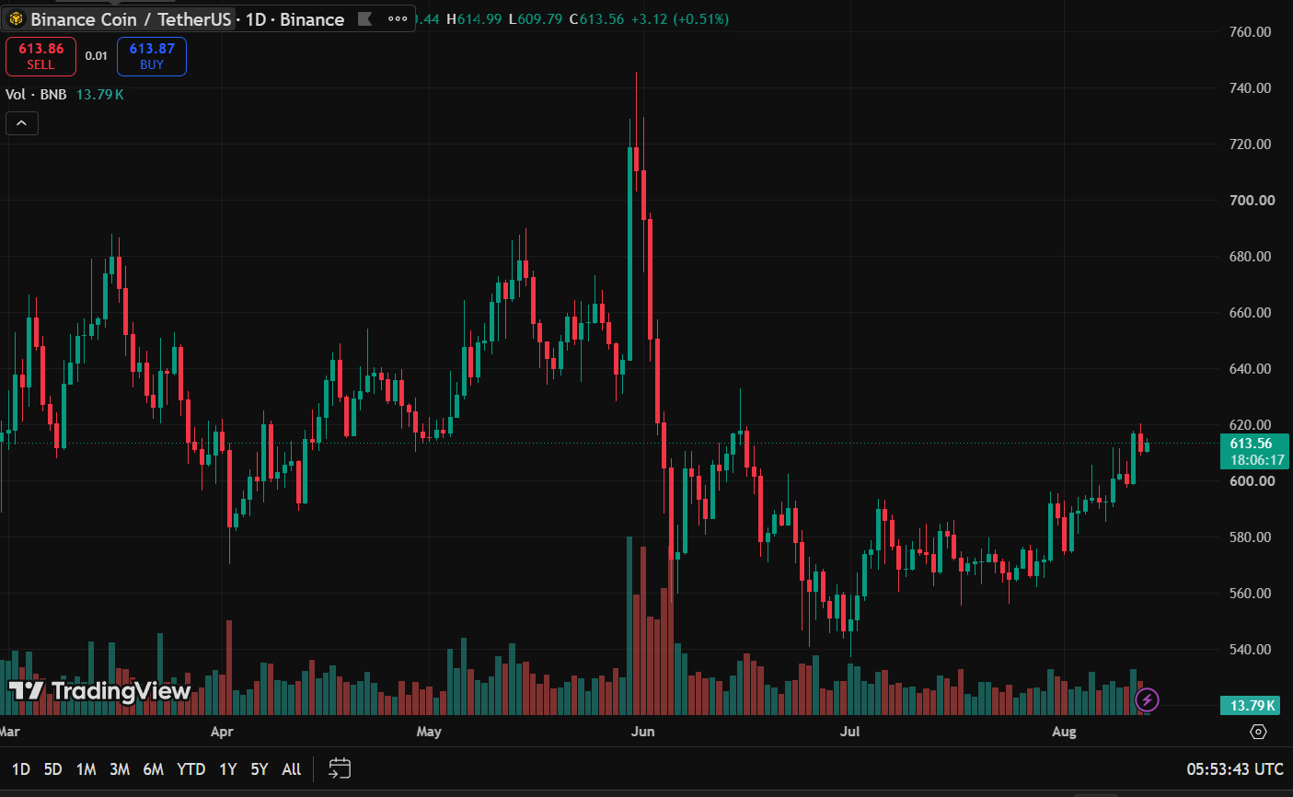

SOLAED:

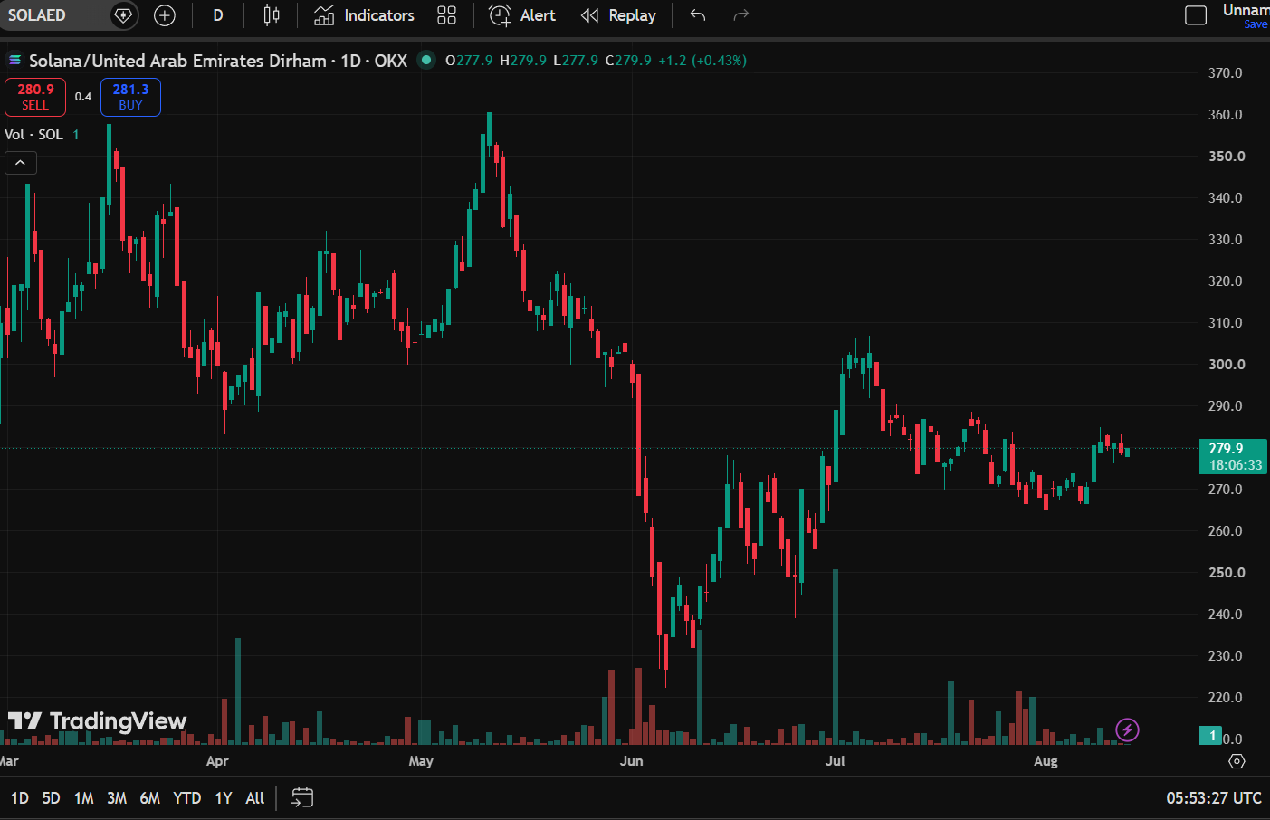

XRP:

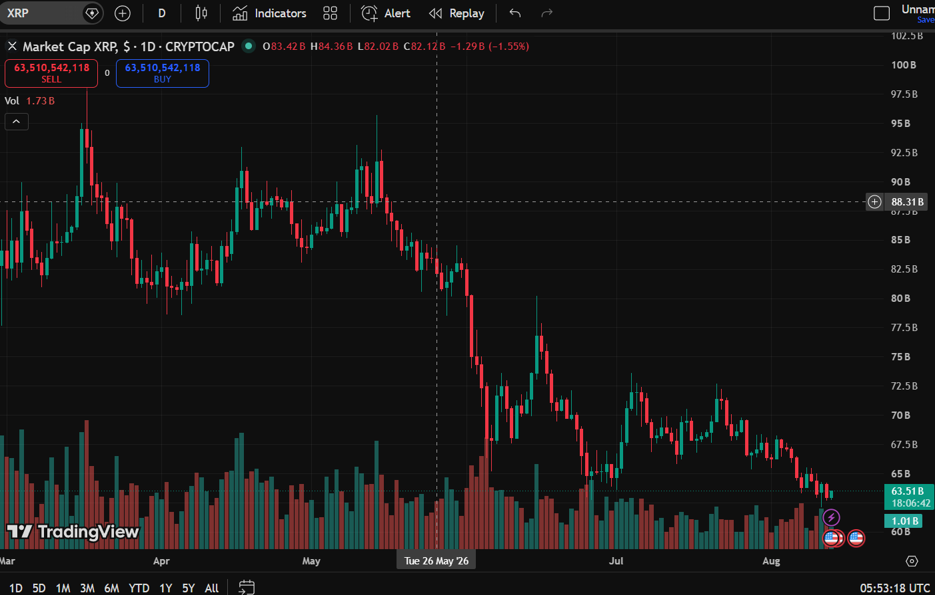
ETHUSD:

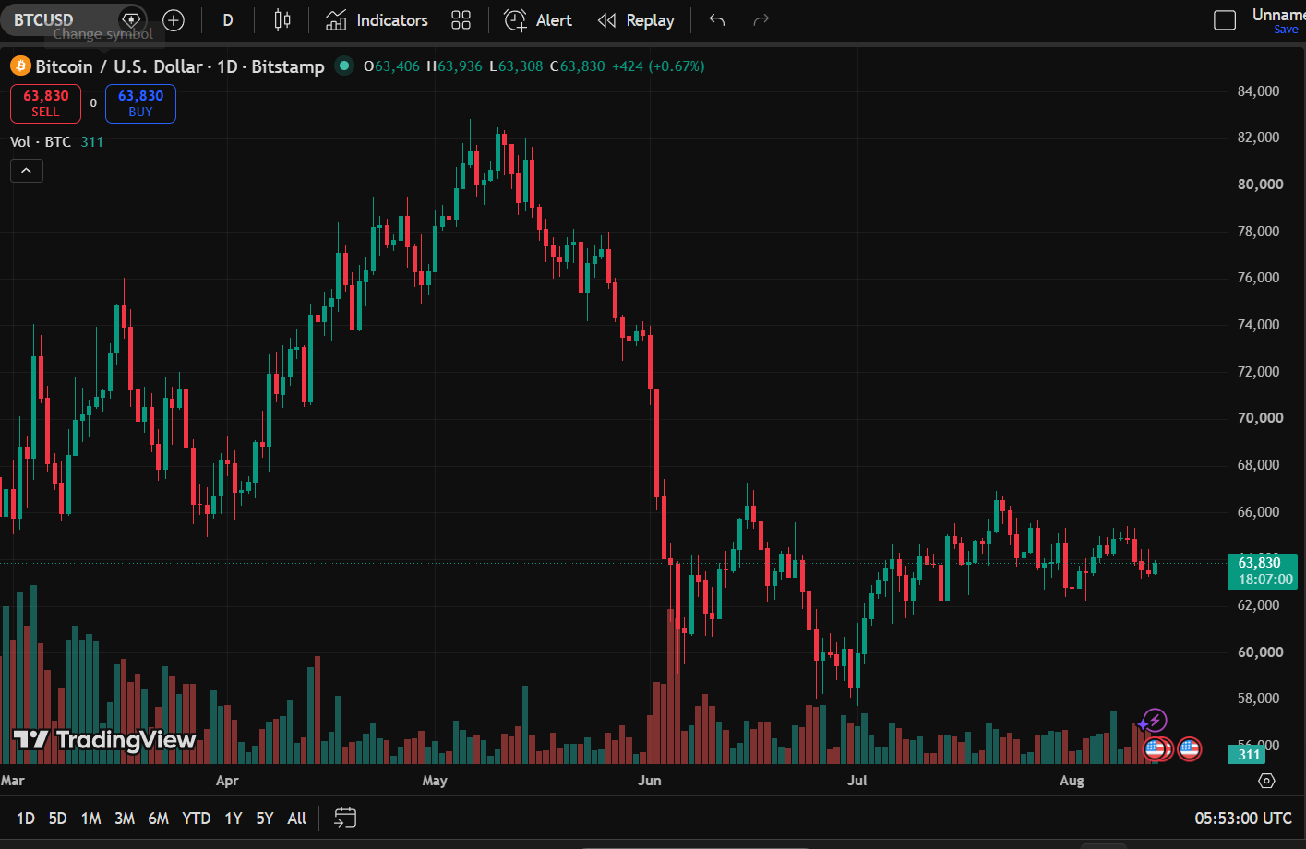

BITCION:

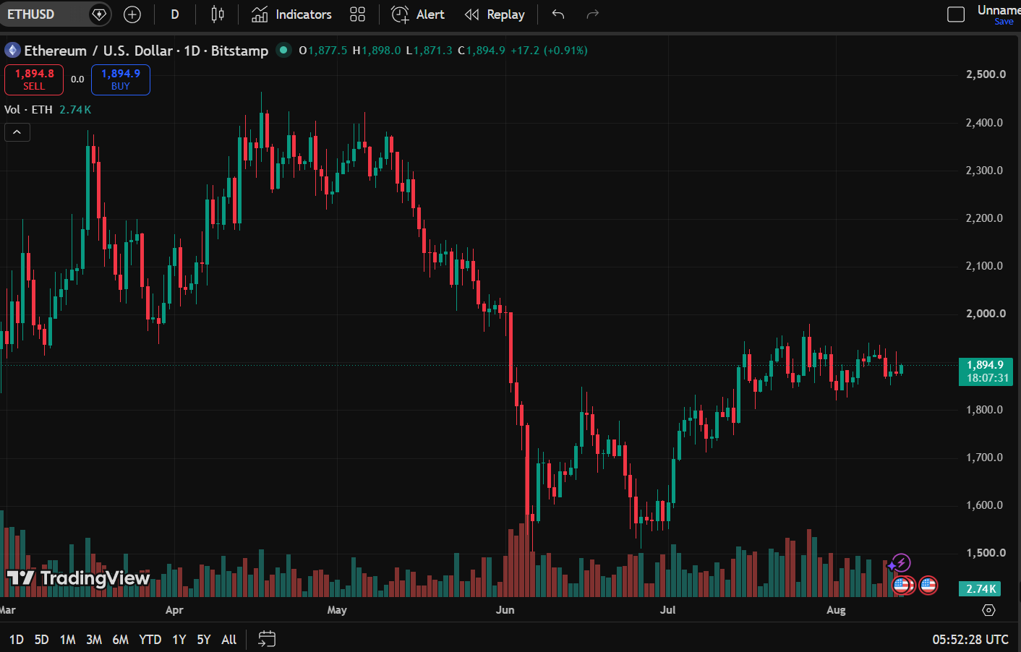

Screenshot of executed buy order/open position :

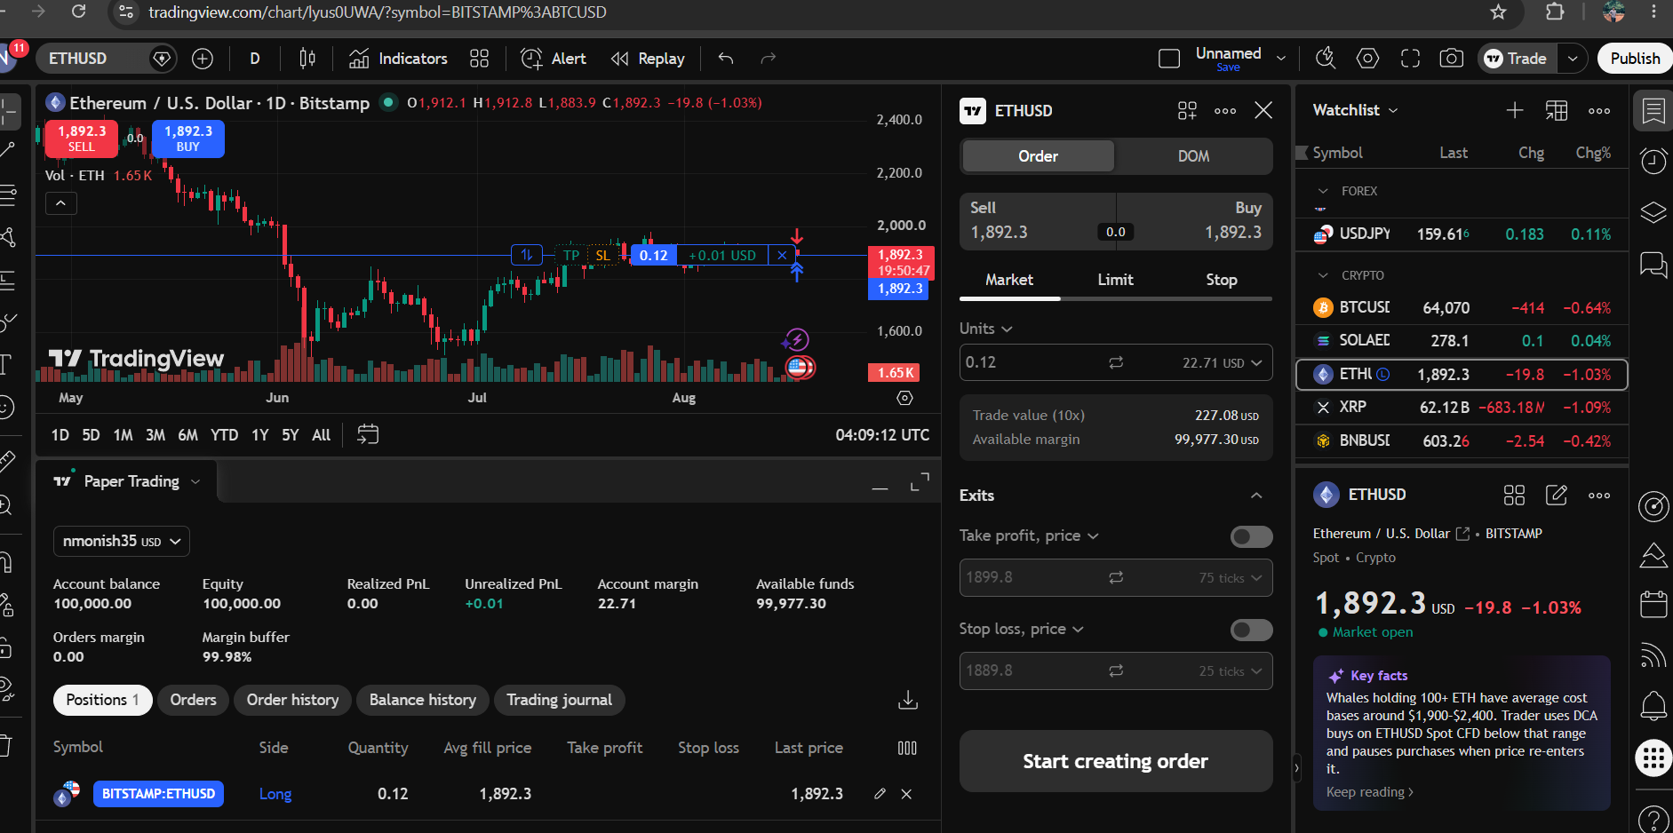

First Trade Record:
Trade Details:

Particulars | Details
Asset Name | ETHUREM
Symbol | ETHUSD
Trade Type | buy
Quantity Purchase | 0.12
Average Fill Price | 1,892.3
Trade Value | 227.08 USD
Date And Time | 2026-08-18  09:27:16

Position Observation :

Particulars | Value
Last Price | 1,892.3
Trade Vale | 227.08 USD
Unrealized PnL | +0.01

Particulars | Details
Asset Name | ETHUREM
Symbol | ETHUSD
Trade Type | Sell
Quantity Purchase | 0.12
Purchase Date And Time | 2026-08-18  09:27:16
Average Fill Price (Purchase Price) | 1,892.3
Trade Value | 227.08 USD
Exit Date And Time | 2026-08-18  10:11:16
Exit Price (SellingPrice ) | 1895.01
Final Profit /Loss (Relized PnL) | +0.34
Tade Outcome (profit/Loss) | Profit

